Project Design Phase-II
Data Flow Diagram

Date | 15.11.2022
Team ID | PNT2022TMID07412
Project Name | Web Phishing Detection
Maximum Marks | 4 Marks

Data Flow Diagrams:
A Data Flow Diagram (DFD) is a traditional visual representation of the information flows within a system. A neat and clear DFD can depict the right amount of the system requirement graphically. It shows how data enters and leaves the system, what changes the information, and where data is stored.

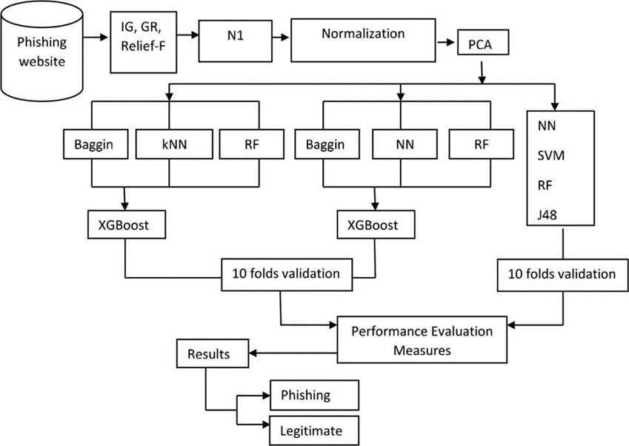

User Type | Functio nal Require ment  (Epic) | User  Story Numbe  r | User Story / Task | Acceptance criteria | Priority | Release
Customer (web user) | Registra tion | USN-1 | As a user,I can register my personal details only in official websites. | I can access my account dashboard. | Medium | Sprint-1
 |  | USN-2 | As a user,I should create strong passwords. | I can access my Account more safely. | High | Sprint-1
 |  | USN-3 | As a user,I can register in websites which does not navigateme to any other websites. | I can store my details incorrect websites. | Low | Sprint-2
 | Login | USN-4 | As a user,I can login into required websites. | I can access my account. | Low | Sprint-1
Customer  (Mobile user) | Registra tion | USN-5 | As a user, I can register with verification code. | This protects from strangers. | High | Sprint-1
 |  | USN-6 | As a user,I should not register at unknow or random calls. | I can be safe from attacks. | Medium | Sprint-1
 |  | USN-7 | As a user, I should not register in other devices. | I can access in my device. | Low | Sprint-2
Administrator |  | USN-8 | Admin should maintain his/her database safely. | This reduces form phishing. | High | Sprint-2
Customer care |  | USN-9 | As a user, If my account is phished. | I can complain. | High | Sprint-1
 |  | USN-10 | As a user,I should not take others information. | I can be punished for it. | Medium | Sprint-1

